How to Register Players in Wholegame
Managers should log into the wholegame and then click on ‘Player Registration’ which can be found on the left hand side of screen (see screen shot below)
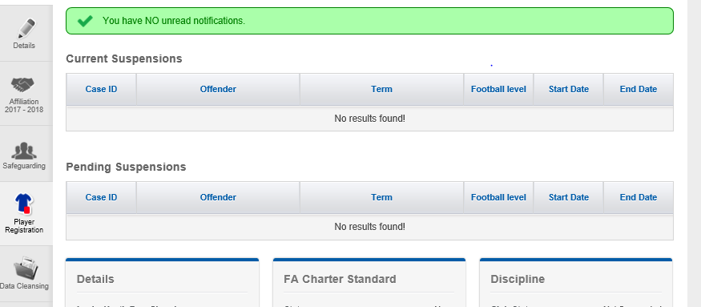

You should then see a list of players that you have assigned to your team.
Either individually click on the players you wish to register or click on the button which is shown below. Clicking on this button will select all your players.

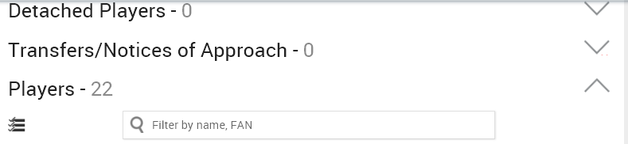

Once you have clicked on a player, you need to then click on the ‘Request Consent button.

This will then send an email to the player requesting him to accept the request. The player should receive the email within the hour of the request being sent. The wholegame will show under the players name that the request is pending (in orange)
When the player accepts registration, you should see the colour change to green and the ‘consent accepted online’
You should then click on ‘Submit to League’. This will send an email to the league secretary to either accept or reject. You should also send a copy of the registration form which can be found on the SCFL website.
Once the league secretary is in receipt of both the copy (can be a scan/picture of the form), and the notification from the wholegame, then they will proceed with your request.
When completed you should see the following under the players name.
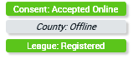

Points to remember
Until you have confirmation from the league secretary, your players are ineligible to play, only when you’ve had an email response back from the league is your player eligible.
Try and register as many players at one time, its more efficient for everyone if you can send in bulk requests and not one or two at a time (before the season starts)
When the season starts the same process applies, the league secretary will also let you know if you have signed on more than 30 players.

